**Karan Arora**  **R.L. Institute M: 9416974837**

**Max Time : 1 hr** **Class = 9th Science Test Max Marks : 20**

**FORCES AND LAWS OF MOTION – 1**

1. Which law of motion gives the measure of force? [ 1 ]
2. Define force of friction. [ 1 ]
3. What do you mean by a resultant force? [ 1 ]
4. Define Linear momentum. [ 1 ]
5. Define 1 Newton force. [ 1 ]
6. What is the acceleration produced by a force of 12 N exerted on an object mass 3kg? [ 2 ]
7. When a carpet is beaten with a stick, dust come out of it. Explain. [ 2 ]
8. Why it is advised to tie any luggage kept on the roof of a bus with a rope? [ 2 ]
9. State Newton’s first law of motion. Hence define force and inertia. [ 3 ]
10. The velocity time graph of a ball moving on the surface of a floor is shown in the figure. Find the force acting on the ball if the mass of the ball is 50g. [ 3 ]

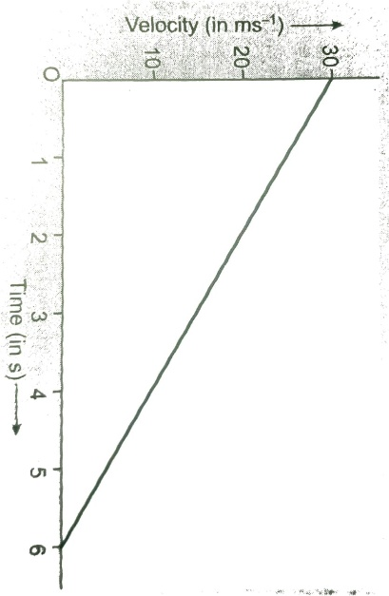

1. A motorcar of mass 1200 kg is moving along a straight line with uniform velocity of 90 Km/h. Its velocity is slowed down to 18 Km/h in 4 sec by an unbalanced external force. Calculate the acceleration and change in momentum. Also calculate the magnitude of the force required. [ 3 ]